Jonathan Oen

A14547654

Pictures for the Solidworks Tutorial

Module 1

Solidworks tutorial

3d Design Overview Solidworks tutorial parts

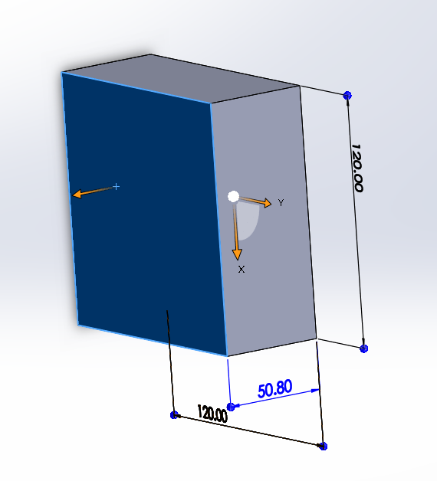 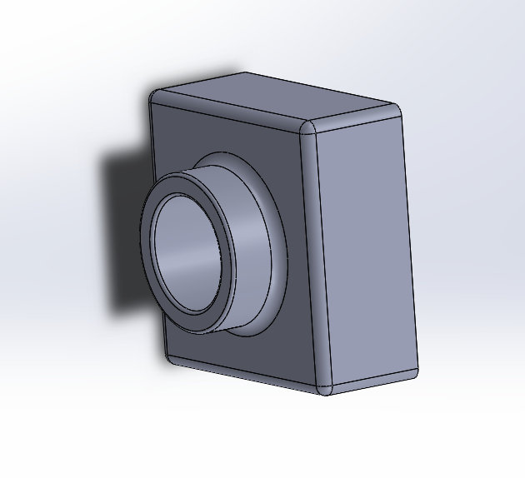

Solidworks tutorial Assembly

